Below is an example CSS file for the Webpage UML profile:

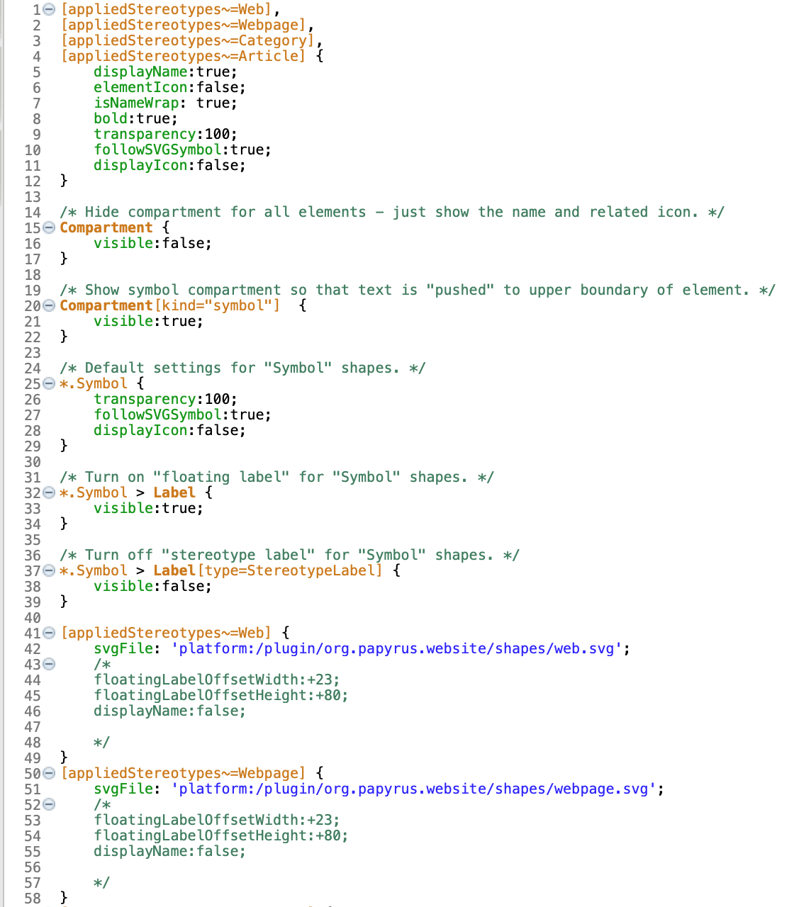

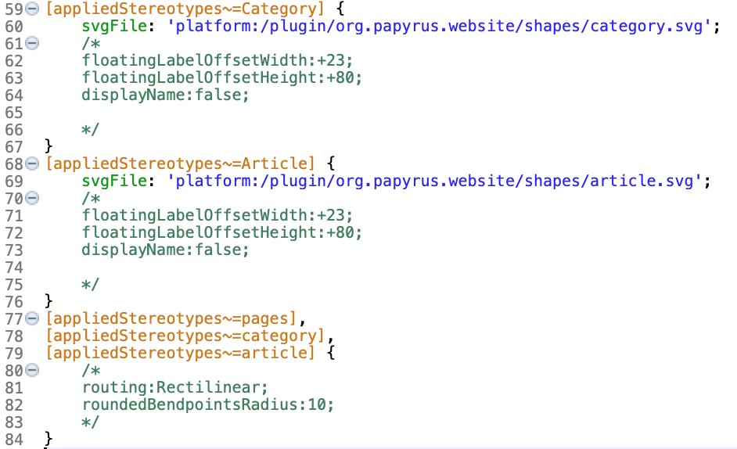**Note: You have 10 minutes to complete this task**